Exp. No: 20
PERFORMANCE EVALUATION OF FREE-SPACE OPTICAL (FSO) LINK UNDER ATMOSPHERIC TURBULENCE USING OPTISYSTEM

OBJECTIVES
- Analyze the effect of range on received power, considering the combined contributions of geometric spreading loss and atmospheric attenuation.
- Evaluate how the combined effects of increasing range and attenuation influence received power and bit error rate (BER).
- Assess the extent to which increased transmit power can compensate for attenuation-induced signal loss.

SOFTWARE REQUIRED
  - Optisystem

EXPERIMENT PROCEDURE
- Design the FSO transmi2er and receiver in OptiSystem using suitable optical source, modulator, photodetector, and receiver components.
- Set input parameters: bit rate, data pa2ern, optical power, and wavelength.
- Connect transmi2er, FSO channel, and receiver; configure transmission range and a2enuation values.
- Connect BER Analyzer, Eye Diagram Analyzer, and Optical Power Meter to monitor performance.
- Vary range and a2enuation, and simulate each condition.
- Record BER, Q-factor, eye diagram, and received power for each case.
- Compare results to analyze the effect of range and a2enuation on FSO link performance.

BLOCK DIAGRAM
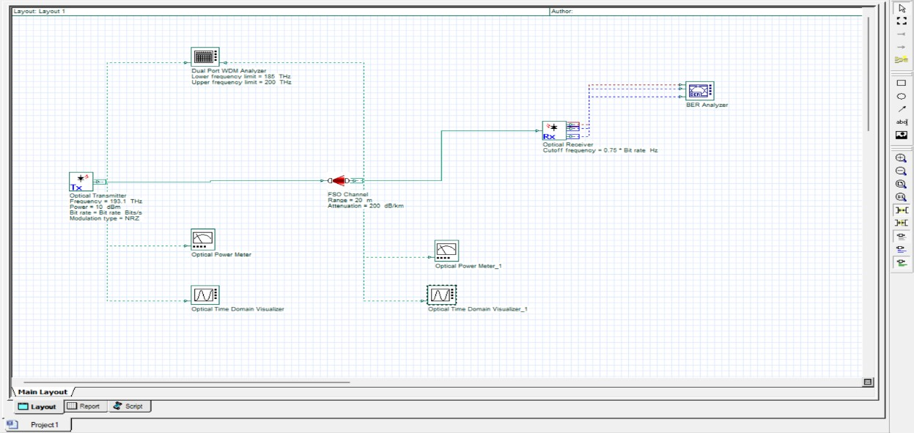

OUTPUT
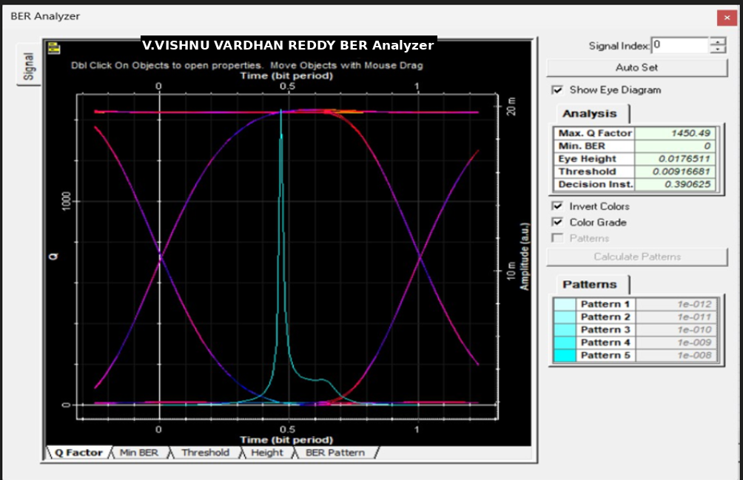

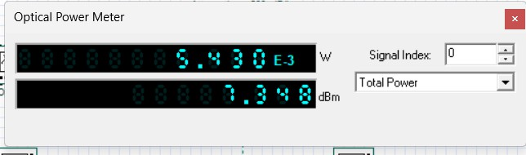

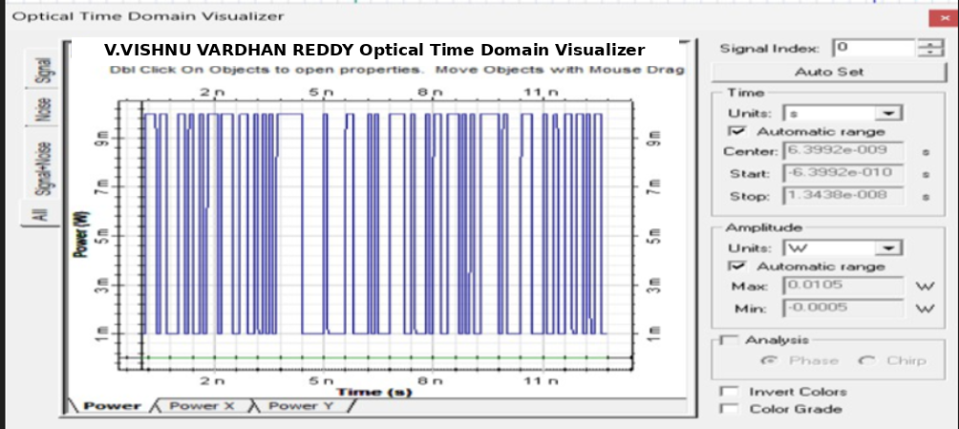

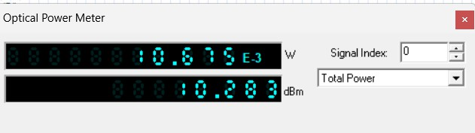

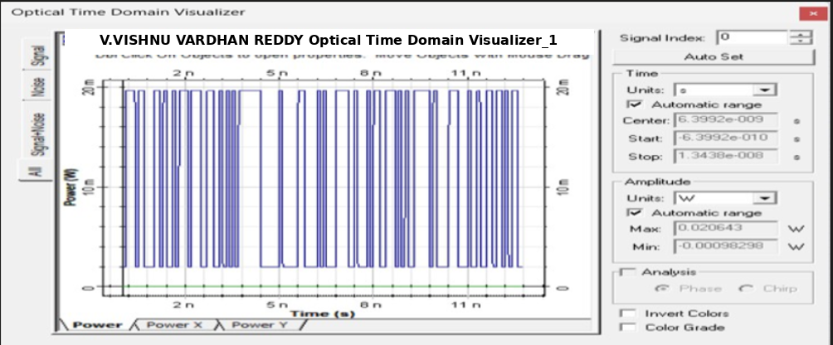

REFLECTION
- Learned the basic principles of Free-Space Optical (FSO) communication and its applications.
- Understood how atmospheric turbulence affects optical signal strength and data transmission.
- Gained practical knowledge of designing and simulating an FSO link using OptiSystem.
- Learned to evaluate system performance using Bit Error Rate (BER), Q-factor, and received optical power.

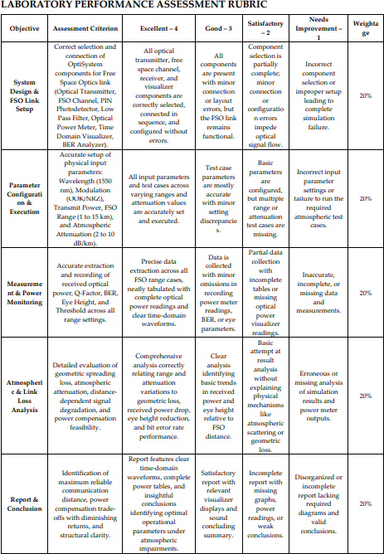

CONCLUSION
The simulation in OptiSystem provides a clear understanding of how FSO systems perform under varying ranges and atmospheric conditions. This analysis helps design robust FSO systems for different applications, ensuring reliable performance in various environments.

